I B. Tech I/II Semester Supplementary Examinations – July, 2025

DISCRETE MATHEMATICAL STRUCTURES

(cse/cse(ai&ml)/it)
Time: 150 Min Max. Marks:60M
SECTION – A
Answer all Four questions 4×8M=32M

1. (a) | In how many ways 5 number of a’s, 4 number of b’s and 3 number of c’s can be arranged so that all the identical letters are not in a single block? | [2M]
(b) | Five teachers are to be made class teachers for five classes one teacher for each class.do not wish to become the class teachers for , for ,and for .In how many ways can the teachers be assigned the work(without displeasing any teacher) | [2M]
(c) | Obtain the solution of the recurrence relation where and | [4M]
2. (a) | Explain the concept of Generalised Pigeonhole Principle | [2M]
(b) | If 45 balls are placed into 9 boxes, use the Generalized Pigeonhole Principle to find the minimum number of balls in at least one box. | [4M]
(c) | Justify your answer to 2(b) using a formula and verify it with a case of 46 balls and 9 boxes. | [2M]
3. (a) | Given the min-terms F(A,B,C,D)=∑(0,2,5,7,8,10)F(A, B, C, D) plot them on a 4-variable K-map. | [2M]
(b) | Identify and group the adjacent 1’s to form prime implicants. | [4M]
(c) | Write the minimal Boolean expression based on the grouping from 3(b). | [2M]
4. (a) | Distinguish In-degree and Out-degree of vertex Explain with an example. | [2M]
(b) | Define the concept of isomorphism. Check whether the following graphs shown in the figure are isomorphic or not.  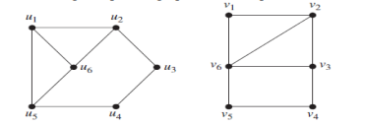 | [4M]
(c) | How do you test the planarity of the graph explain with an example. | [2M]

SECTION - B
Answer all Two questions 2×14M=28M

5.(a) | A certain question paper contains two parts A and B each containing five questions. How many different ways a student can answer six questions by selecting at least two questions from each part | [4M]
(b) | A survey of 500 television viewers of a sports channel produced the following information 285 watch cricket,195 watch hockey,115 watch foot ball,45 watch cricket and football, 70 watch cricket and hockey, 50 watch hockey and football and 50 do not watch any of the three kinds of games.  - How many viewers in the survey watch all three kinds of games?  - How many viewers watch only cricket? | [8M]
(c) | In the above problem of 5(b) If 15 more viewers are added to the survey who only watch cricket, how many total viewers will now be watching only cricket? Also what is the new total number of surveyed viewers? | [2M]
6.(a) | Which graph shown in the figure have an Eulerian path.  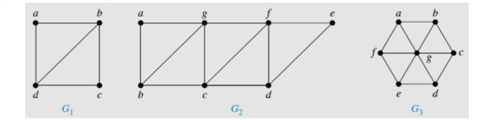 | [2M]
(b) | Using Kruskal’s algorithm, obtain a minimal spanning tree for the graph given:  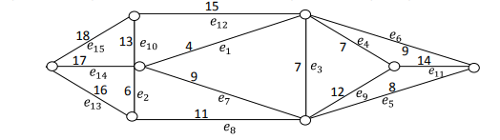 | [6M]
(c) | Write any five difference between Eulerian Graph & Hamiltonian graph | [6M]

